Summary of the Report:
This report provides the analysis regarding the prediction of breast cancer for the seattle grace hospital. The main goal is to develop model which predicts the malignant tumors with few categorical variables. This model uses various regression techniques to check the accuracy.
Model Description:
Firstly, I would say I am successful in creating a machine learning model to predict the malignant tumors. From the data set provided by the seattle grace hospital, I have built the model using Random Forest Regression. Since, Unnamed:0 variable is same as the serial numbers, I have dropped it out since it has nothing to do with my model. The first model was built with default values for the parameter and achieved the c-stat value 0.9925.
Test Parameters:
- n_estimators: The number of trees in the forest.
- max_features: The number of features to consider when looking for the best split.
- min_samples_leaf: The minimum number of samples in newly created leaves.
- n_jobs: Determines if multiple processors should be used to train and test the model.
Model Accuracy:
- The model I have built is 99.25% accurate in predicting the malignancy. However, there are 0.75% chances that it may be falsely predicted. Considering the uniformity of cell shape and uniformity of cell size, the accuracy that I have obtained was 0.9925.
- The chances that it may miss the malignancy is 0.75%

Model Comparison:
There is not much change in the model after considering the auto, sqrt and log 2 as Max_features. I have run the model for 3 max features and compared them.

Bar Chart:

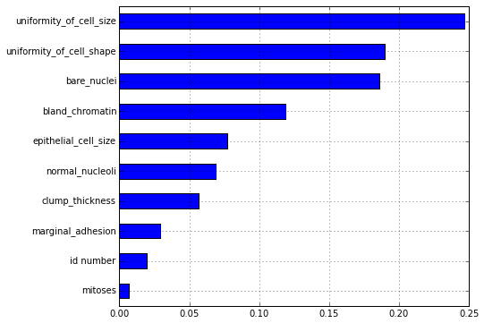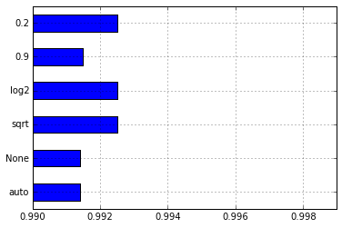

Explanation:

From the chart, we can understand that the variables bare nuclei, epithelial cell size are the most important variables in predicting the breast cancer. Uniformity of cell size can also be considered and it plays a role in determining the c-stat value.

If we consider, the True positive value and false positive value against each other and plot the ROC curve, it will be like below:
